Test Case 1

**Section:** Log in on site

**Precondition:**

**Open cite** <https://rozetka.com.ua/ua/cart/>

On site must be line with Name, Last Name, Phone number, Mail address and Password

**Steps**

1. Enter correct Information on site

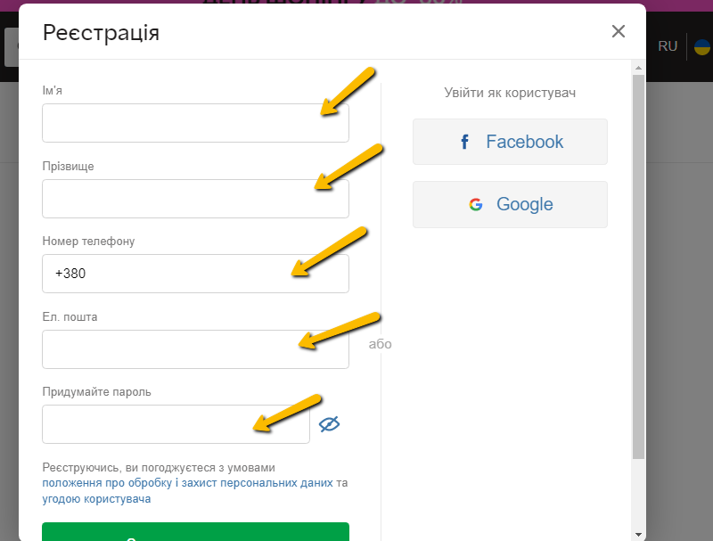

**Step 2**

Confirm phone number

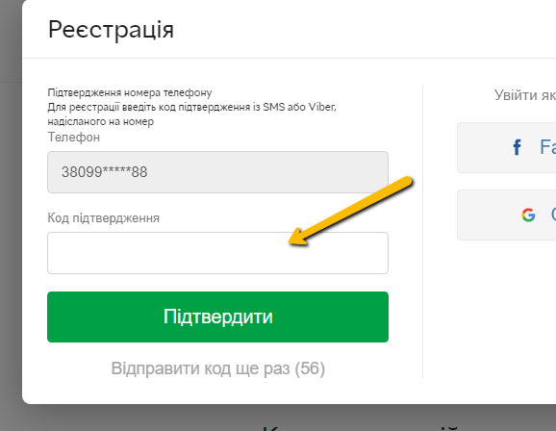

**Expected results:**

Open cite <https://rozetka.com.ua/ua/cabinet/personal-information/>

Must be page with personal information with Headers:

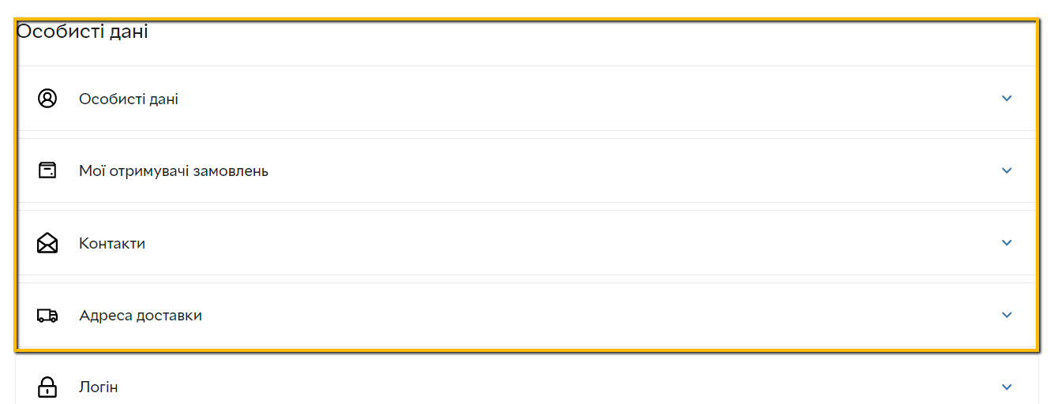

Personal Information

My order recipients

Contacts

Delivery Adress

Login

Pets

Additional Information